FleetWise
User Guide
Author: Vivek Chaurasia Email: vivekc03@umd.edu UMD Directory ID: 120980275 Date: November 2025

Contents

- User Roles and Access 4
  - Fleet Manager . . . . . . . . . . . . . . . . . . . . . . . . . . . . . . . . . 4
  - Fleet User . . . . . . . . . . . . . . . . . . . . . . . . . . . . . . . . . . . 4
- Getting Started 4
  - Accessing the Application . . . . . . . . . . . . . . . . . . . . . . . . . . 4
  - Login Credentials . . . . . . . . . . . . . . . . . . . . . . . . . . . . . . . 4
  - Registration . . . . . . . . . . . . . . . . . . . . . . . . . . . . . . . . . . 4
- Security Features 5
  - Password Requirements . . . . . . . . . . . . . . . . . . . . . . . . . . . . 5
  - Account Security . . . . . . . . . . . . . . . . . . . . . . . . . . . . . . . 5
    - Account Lockout . . . . . . . . . . . . . . . . . . . . . . . . . . . 5
    - Session Management . . . . . . . . . . . . . . . . . . . . . . . . . 6
  - Rate Limiting . . . . . . . . . . . . . . . . . . . . . . . . . . . . . . . . . 6
  - Data Protection . . . . . . . . . . . . . . . . . . . . . . . . . . . . . . . . 6
  - Security Monitoring . . . . . . . . . . . . . . . . . . . . . . . . . . . . . . 7
- Fleet User Features 7
  - User Dashboard . . . . . . . . . . . . . . . . . . . . . . . . . . . . . . . . 7
  - Browsing Vehicles . . . . . . . . . . . . . . . . . . . . . . . . . . . . . . . 7
  - Checking Availability via Chatbot . . . . . . . . . . . . . . . . . . . . . . 8
  - Viewing Your Reservations . . . . . . . . . . . . . . . . . . . . . . . . . . 8
- Fleet Manager Features 8
  - Manager Dashboard . . . . . . . . . . . . . . . . . . . . . . . . . . . . . 8
  - Vehicle Management . . . . . . . . . . . . . . . . . . . . . . . . . . . . . 9
    - Add a Vehicle . . . . . . . . . . . . . . . . . . . . . . . . . . . . . 9
    - Edit or Delete a Vehicle . . . . . . . . . . . . . . . . . . . . . . . 9
  - Reservation Management . . . . . . . . . . . . . . . . . . . . . . . . . . . 9
    - Create a Reservation . . . . . . . . . . . . . . . . . . . . . . . . . 9
    - Process Vehicle Return 10
    - View All Reservations 10
- Use Case Scenarios 11
  - Use Case 1: Checking Vehicle Availability 11
  - Use Case 2: Manager Creating a Reservation 11
  - Use Case 3: Processing a Vehicle Return 11
  - Use Case 4: User Reviewing Reservations 11
- Security Guidelines for Users 12
  - Best Practices 12
  - Understanding Rate Limits 12
- Troubleshooting 13
  - Common Issues and Solutions 13
  - Getting Additional Help 14
  - Reporting Security Issues 14
- Frequently Asked Questions 14
  - Account Questions 14
  - Feature Questions 15
  - Technical Questions 15
- Appendix: System Requirements 15
  - Browser Compatibility 15
  - Network Requirements 15
  - Screen Resolution 15
- Conclusion 16

User Roles and Access
FleetWise supports two main roles, each with different permissions and views:

Fleet Manager
Administrators with full system control:
- Manage vehicle inventory (add, edit, delete)
- Create, process, and complete reservations
- Monitor fleet utilization and vehicle status
- View all users and reservation history

Fleet User
Standard users with limited privileges:
- Browse available vehicles
- Check availability using the built-in chatbot
- View their own reservations
- Contact the Fleet Manager for new bookings

Getting Started

Accessing the Application
After successful setup, open a web browser and navigate to:
http://localhost:5173

Login Credentials
Use one of the following credentials to sign in:
- Fleet Manager: manager1@fleetwise.com / Manager@123
- Fleet User: john@example.com / Password@123

Registration
If self-registration is enabled:
- Click the ”Register” link on the login screen
- Fill in the form with your name, email, and password
- Select your role (Fleet User or Fleet Manager)

- Submit to create an account
Note: Screenshots show the login and registration interfaces.

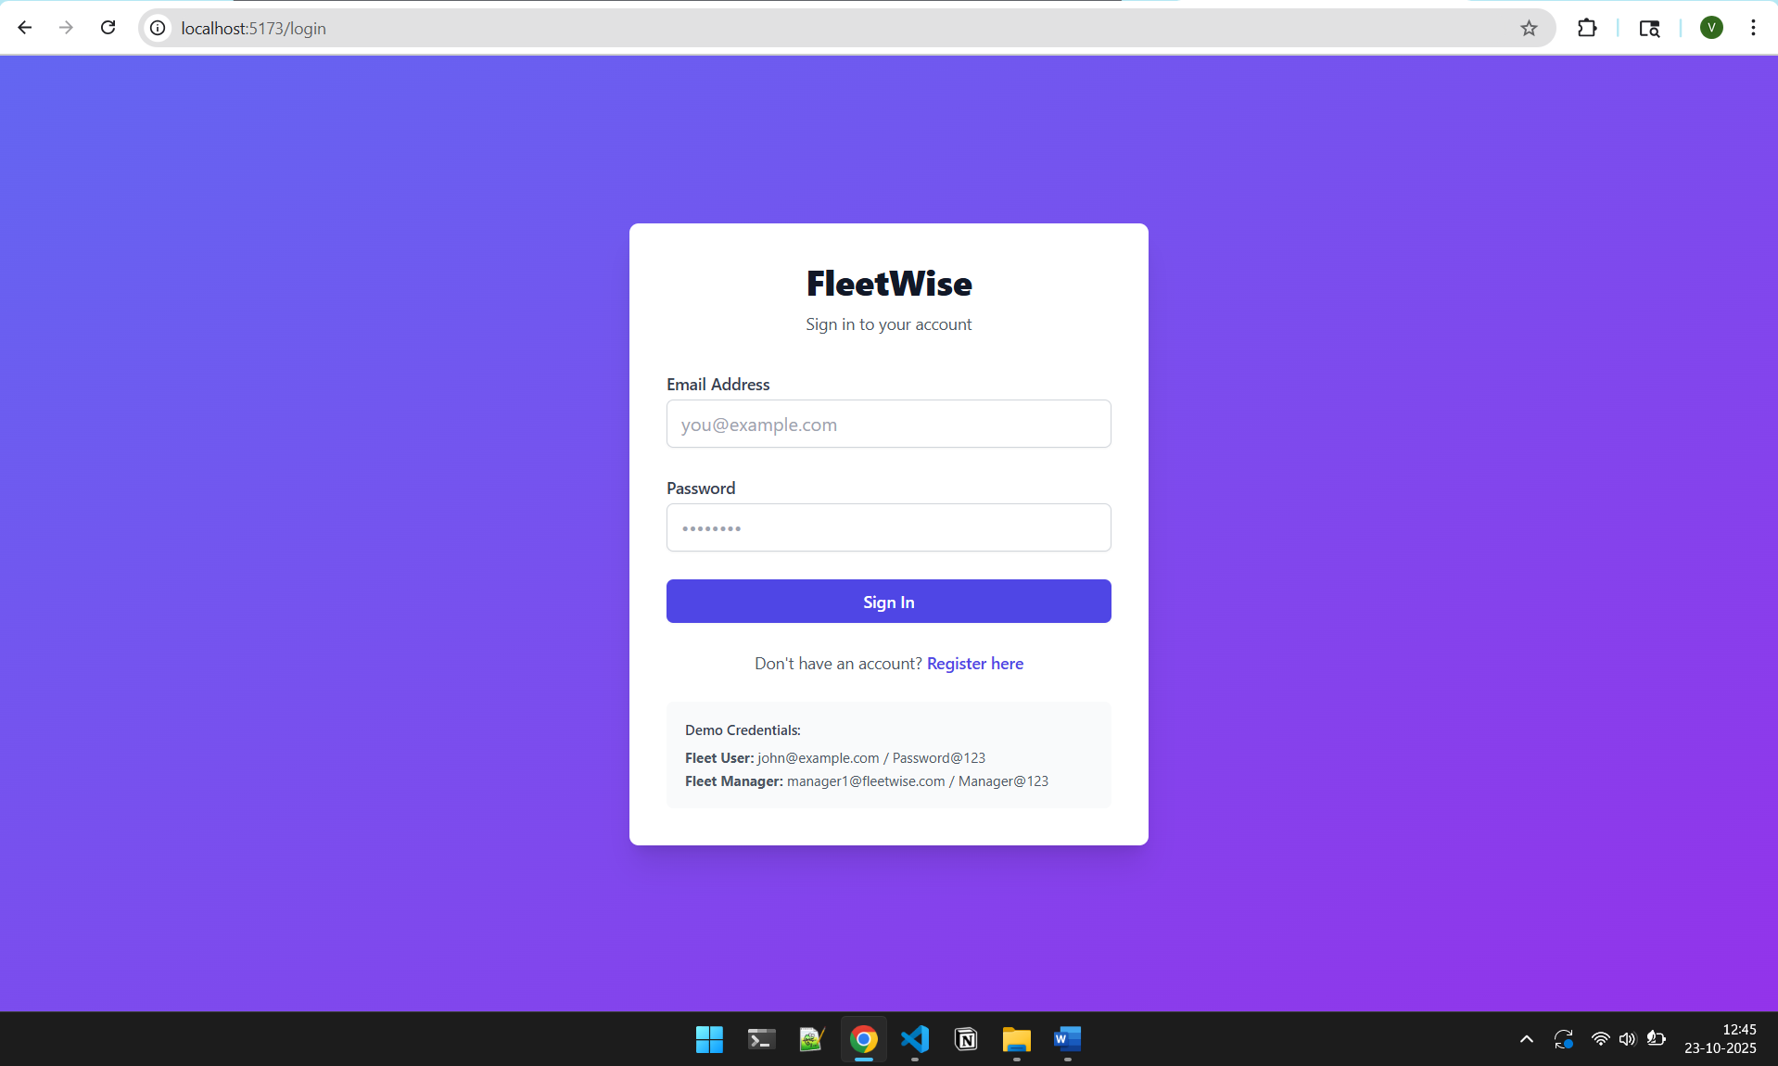

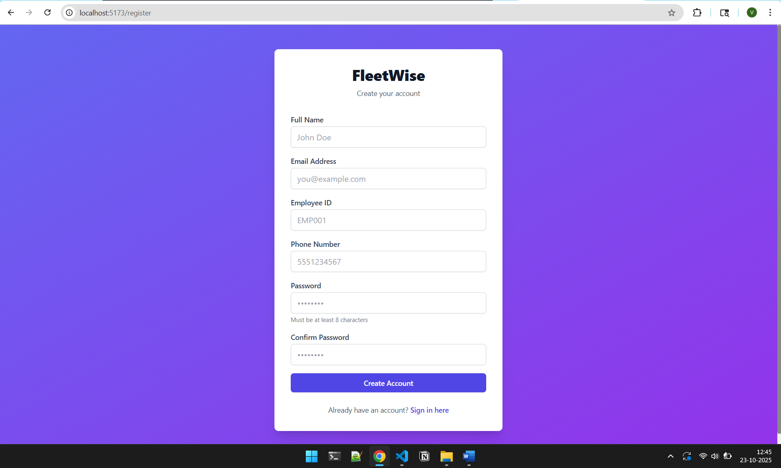

Security Features

Password Requirements
FleetWise implements strong password requirements for account security:
Your password must contain:
- Minimum 8 characters
- At least one uppercase letter (A-Z)
- At least one lowercase letter (a-z)
- At least one number (0-9)
- At least one special character (!@#$%ˆ&*)
Example valid passwords:
- Password@123
- Fleet$ecure2024
- MyP@ssw0rd!

Account Security

Account Lockout
To protect against unauthorized access attempts:
      - After 5 failed login attempts, your account will be locked
      - Lockout duration is 15 minutes
      - During lockout, you cannot log in even with correct credentials
      - After 15 minutes, you can try logging in again
      - Failed login attempts are tracked by email address
      - IP addresses with repeated violations may face temporary blocks
Important
If you forget your password or get locked out, contact your Fleet Manager or system administrator at vivekc03@umd.edu

Session Management
      - Your login session expires after 30 minutes of inactivity
      - You will be automatically logged out for security
      - You can manually log out at any time using the logout button
      - Never share your login credentials with others
      - Sessions are tracked and validated with each request
      - Multiple concurrent sessions are limited to 3 per user

Rate Limiting
FleetWise implements rate limiting to prevent system abuse:
Login Attempts:
- Maximum 20 login attempts per minute
- Exceeding this will temporarily block login attempts
Chatbot Usage:
- Maximum 15 chatbot queries per minute
- This prevents system overload
- If you hit the limit, wait 1 minute before trying again
API Requests:
- General API operations limited to 200 requests per minute
- Normal usage will never hit this limit

Data Protection
Your information is protected through:
- Password Encryption: All passwords are encrypted using bcrypt
- Secure Communication: Data is transmitted securely
- Access Control: You can only see your own reservations
- Audit Logging: All system actions are logged for security
- Input Validation: All user inputs are validated and sanitized
- SQL Injection Protection: Database queries use parameterized statements
- Failed Login Tracking: Failed login attempts are monitored and tracked

Security Monitoring
FleetWise implements comprehensive security monitoring through dedicated security ta-bles:
- Authentication Events: All login attempts (successful and failed) are logged
- Security Events: Suspicious activities are automatically detected and logged
- Rate Limit Violations: Excessive requests are tracked and blocked
- Input Validation Failures: Invalid or malicious inputs are logged
- System Errors: Technical issues are monitored for security implications
- Failed Login Tracking: Dedicated table tracks failed login attempts by email and IP
- Audit Trail: Complete audit log of all user actions and system changes
Note: All security logs are retained for 90 days and are available to system adminis-trators for analysis.

Fleet User Features

User Dashboard
Once logged in as a Fleet User, you will see:
- Number of available vehicles
- Your active reservations count
- Chatbot access button for availability checks

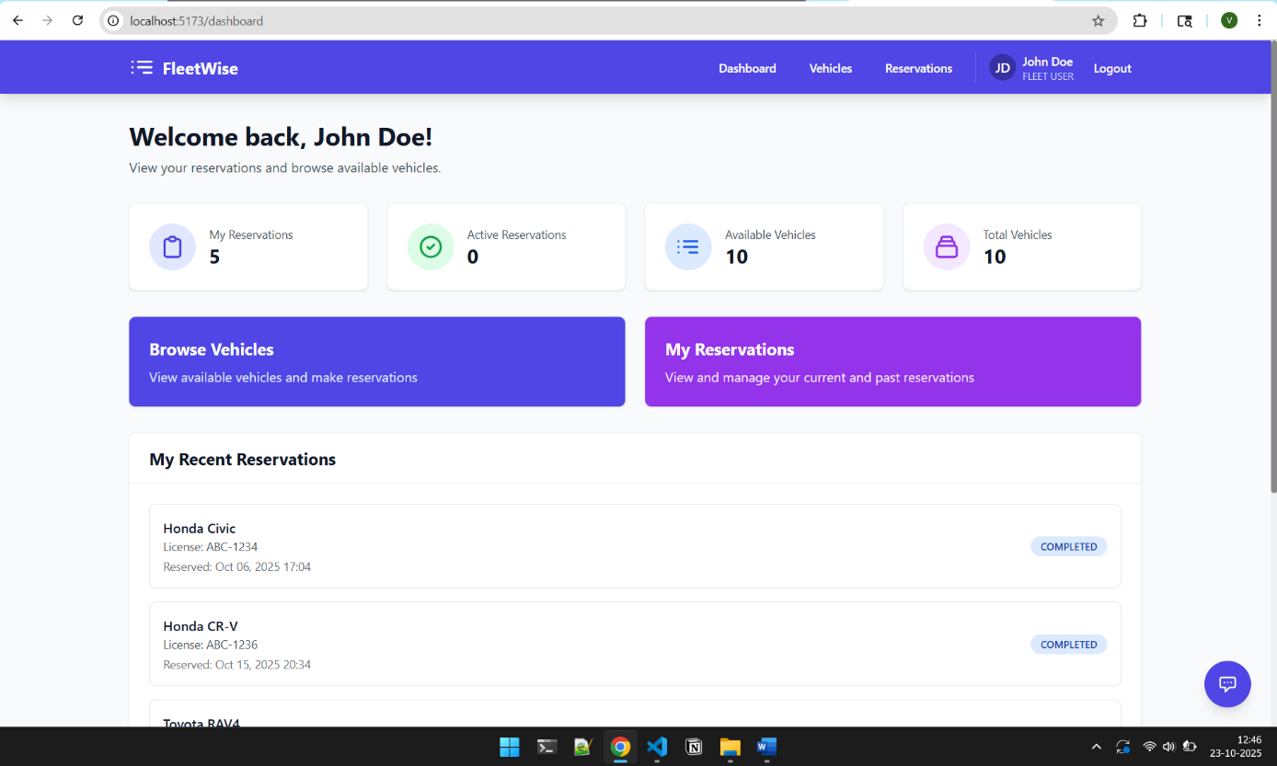

Browsing Vehicles
- Select ”Vehicles” from the navigation menu
- Review details such as make, model, year, type, and rate
- Vehicles are labeled as Available or Rented

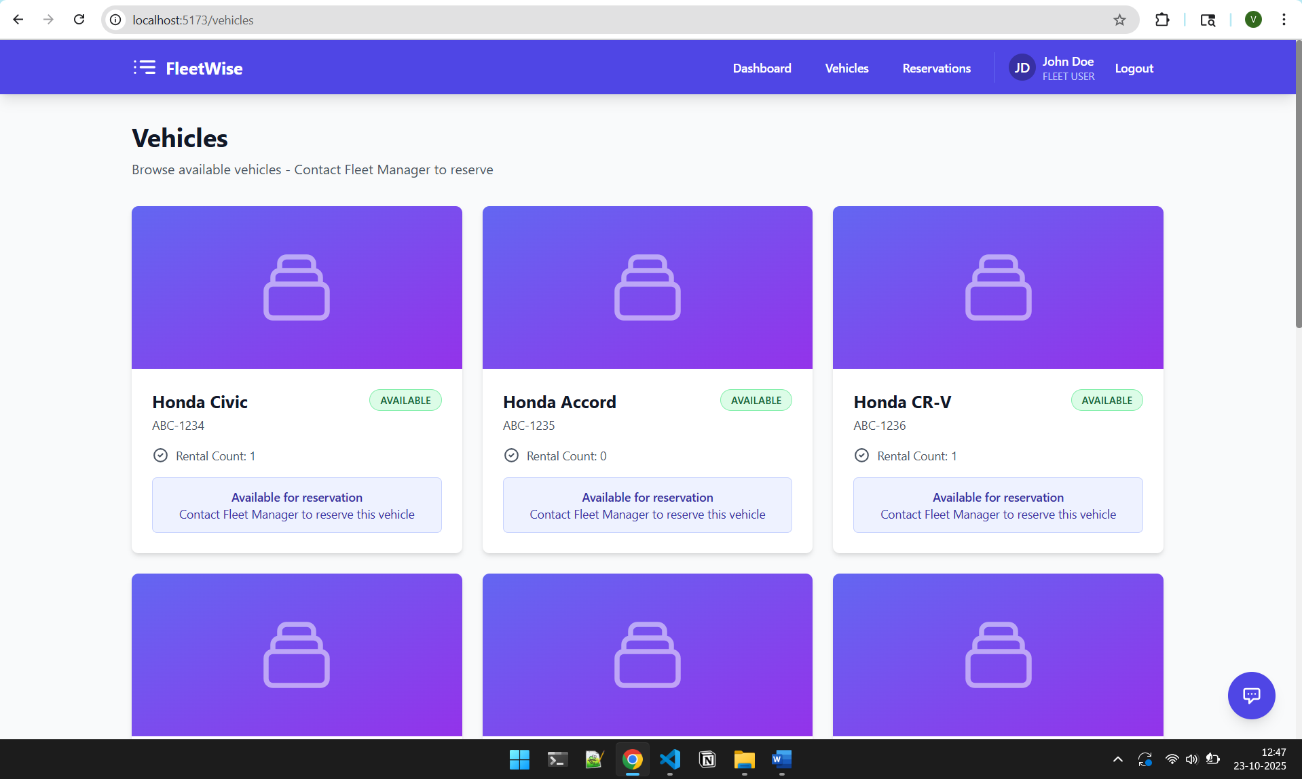

Checking Availability via Chatbot
FleetWise provides a conversational chatbot for quick searches:
- Click the chatbot icon on the screen
- Choose a manufacturer (e.g., Toyota, Ford, Honda)
- Select a specific model to check its status
- The chatbot will respond with availability and daily rate
Chatbot Rate Limit: Remember, you can make up to 15 chatbot queries per minute.

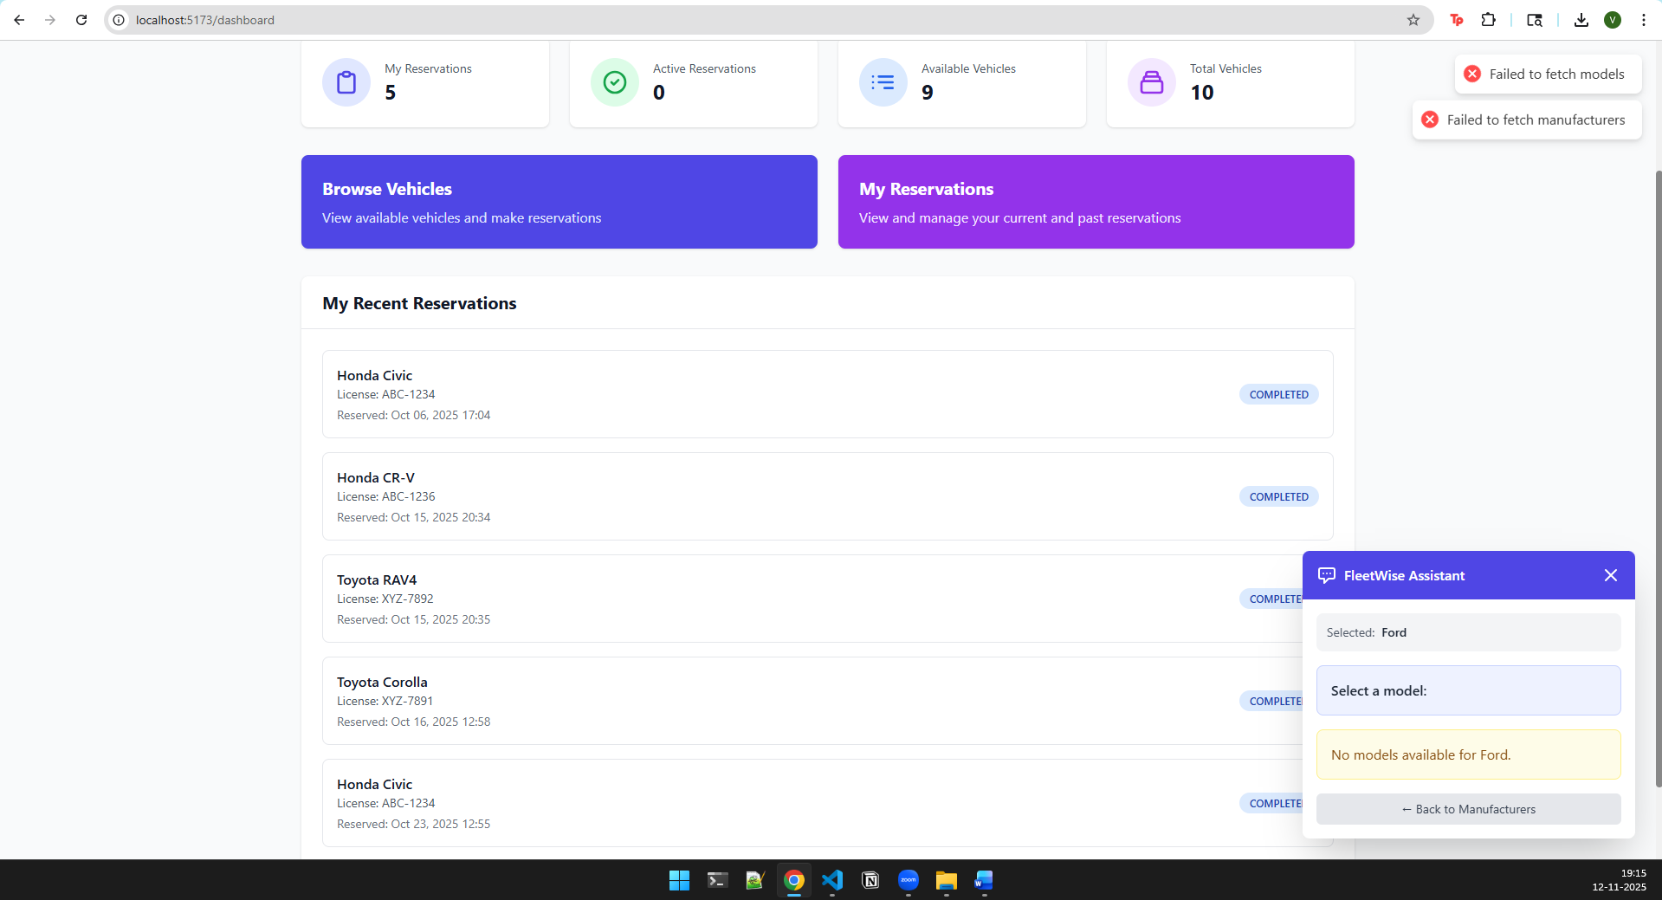

Viewing Your Reservations
Fleet Users can review all their active and completed reservations:
- Navigate to ”My Reservations”
- Review start and end dates, total cost, and status
- Completed reservations are marked as Completed
Security Note: You can only see your own reservations. Other users’ reservations are not visible to you.

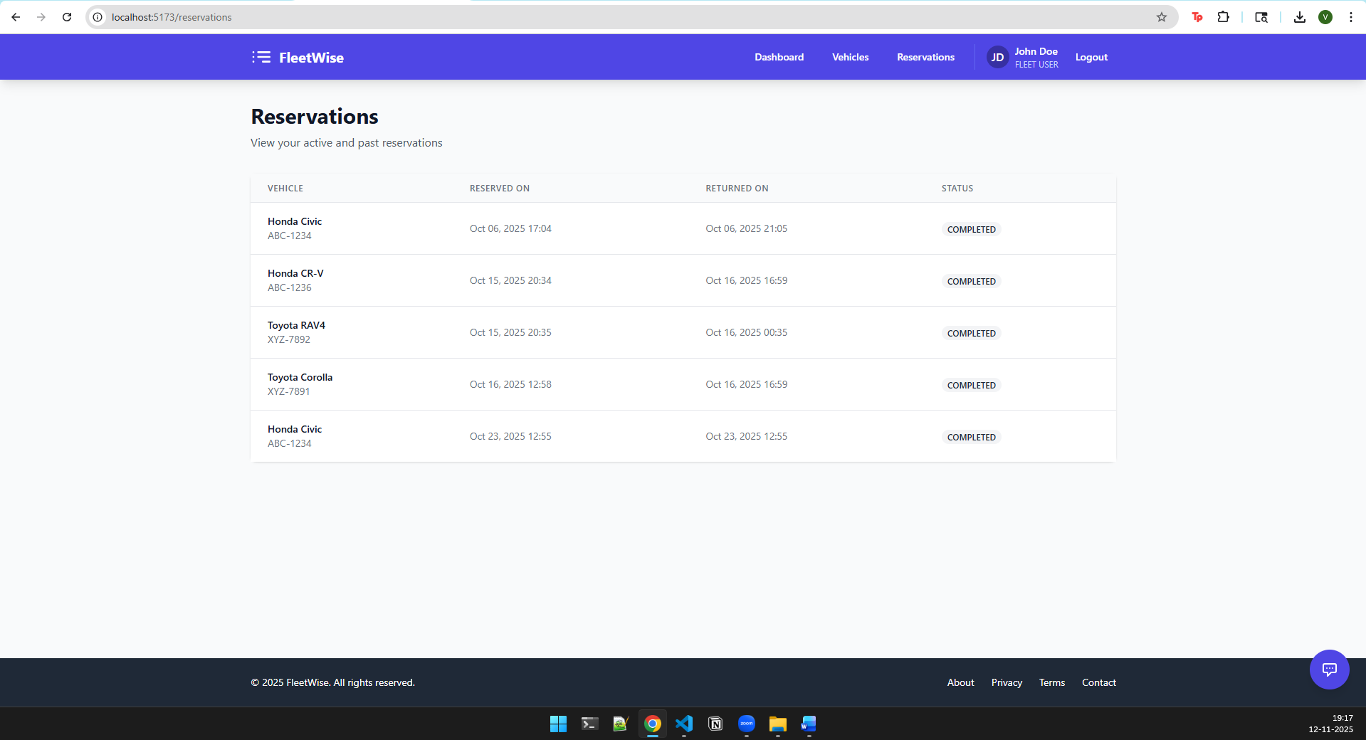

Fleet Manager Features

Manager Dashboard
Fleet Managers have access to system-wide metrics:
- Total vehicles in the system
- Count of available and rented vehicles
- Active reservations

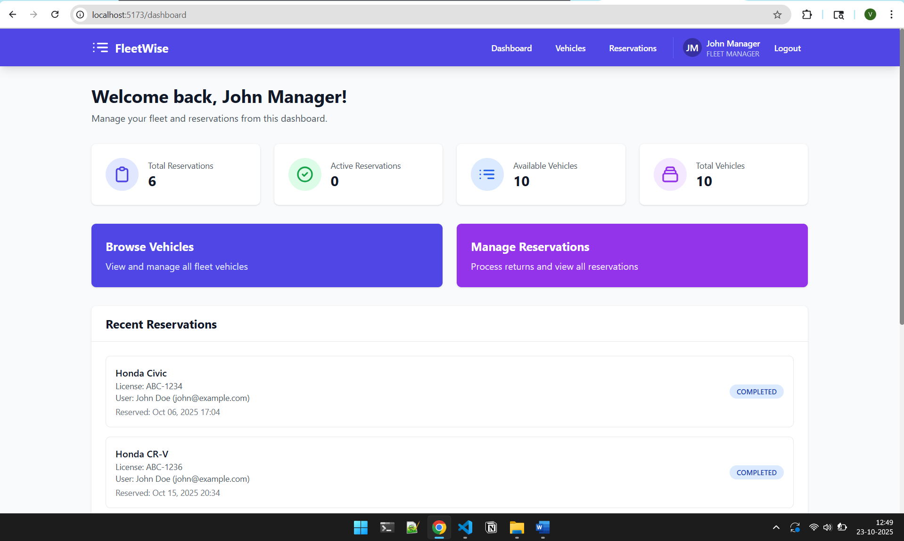

Vehicle Management
Fleet Managers can add, edit, or remove vehicles as required.

Add a Vehicle
- Navigate to the ”Vehicles” section
- Click ”Add Vehicle”
- Enter details such as make, model, license plate, etc.
- Click ”Save” to confirm
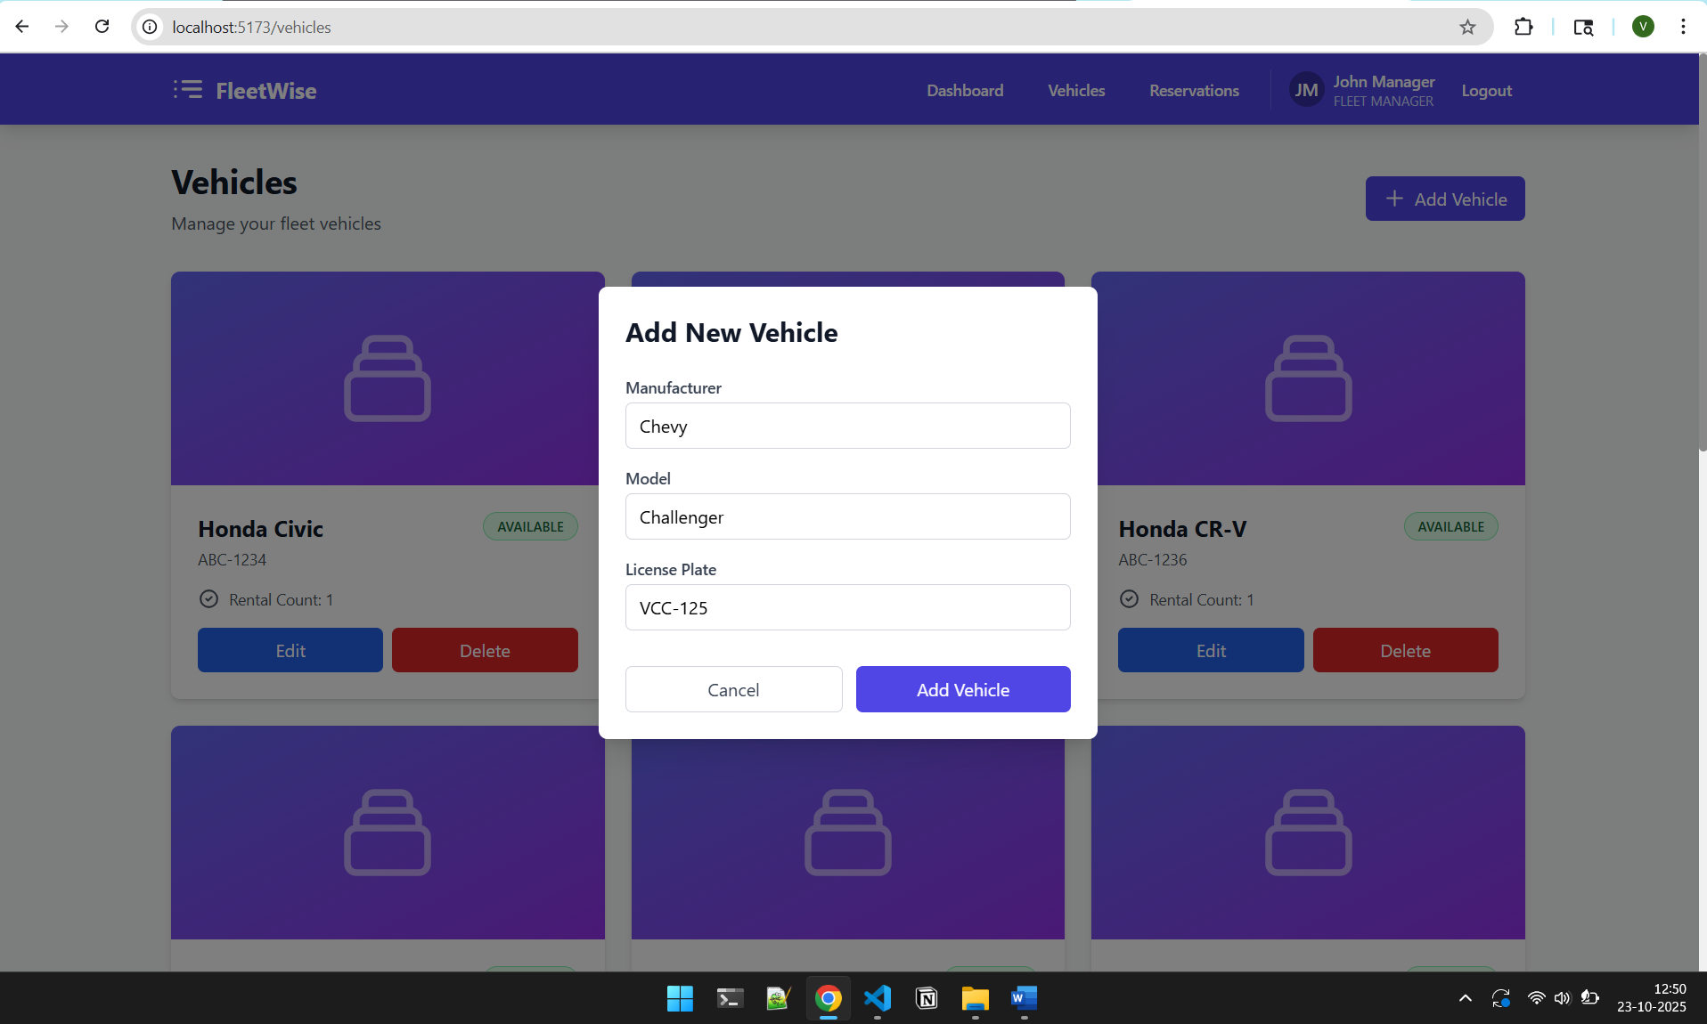
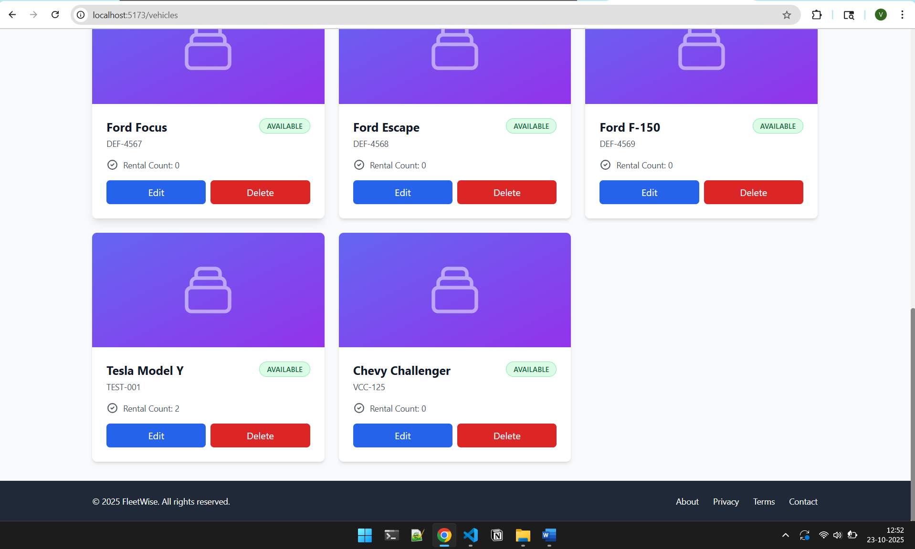

Input Validation: All vehicle data is validated for security:
  - License plate must be unique
  - All fields are sanitized to prevent injection attacks
  - Invalid data will show clear error messages
  - Dangerous characters are automatically removed or blocked
  - Input length limits prevent denial-of-service attacks

Edit or Delete a Vehicle
      - Use the ”Edit” button to update details
      - Vehicles marked as ”Rented” cannot be deleted
      - All changes are logged for security audit
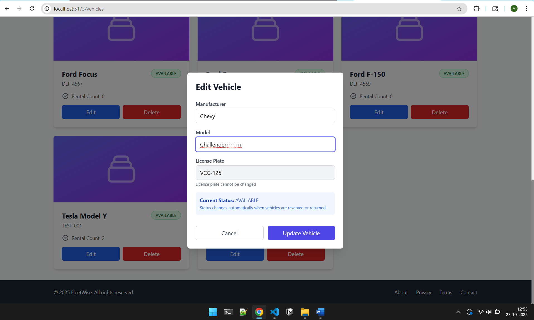

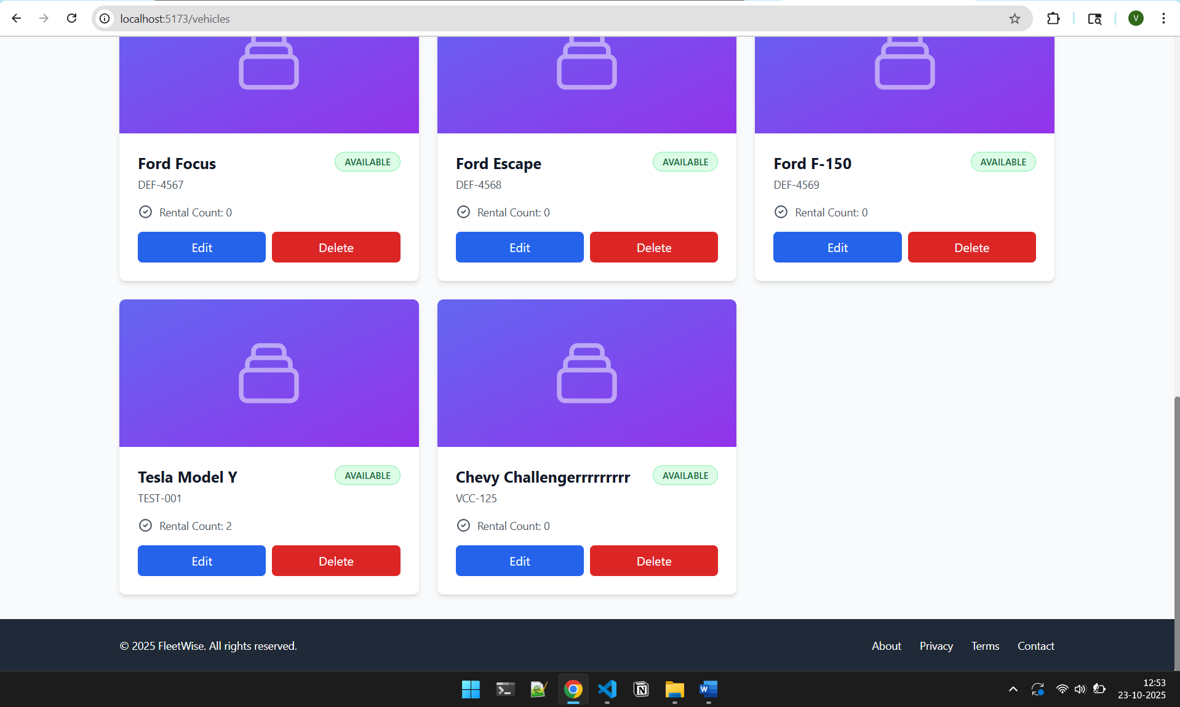

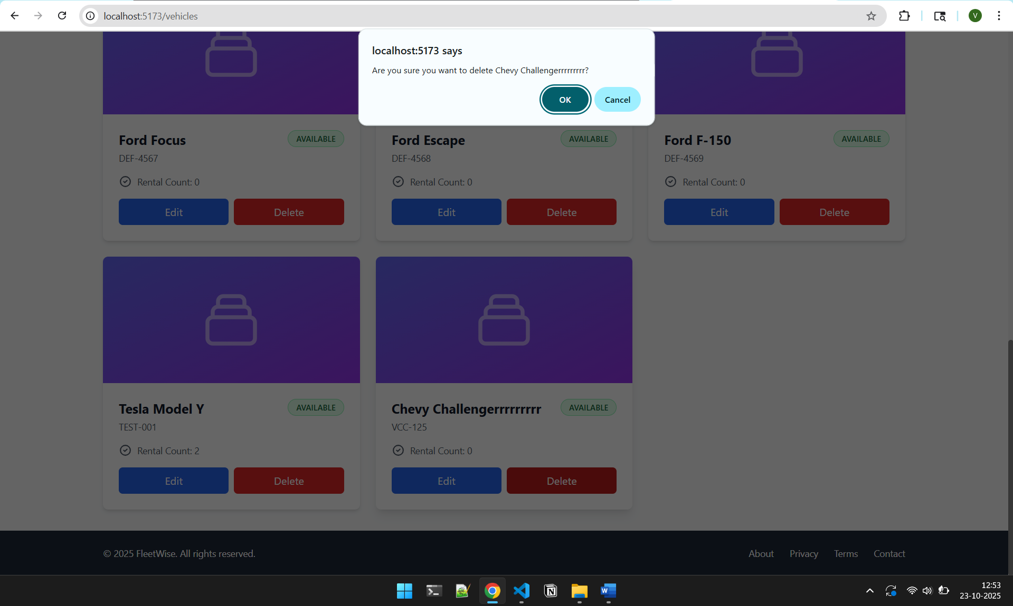

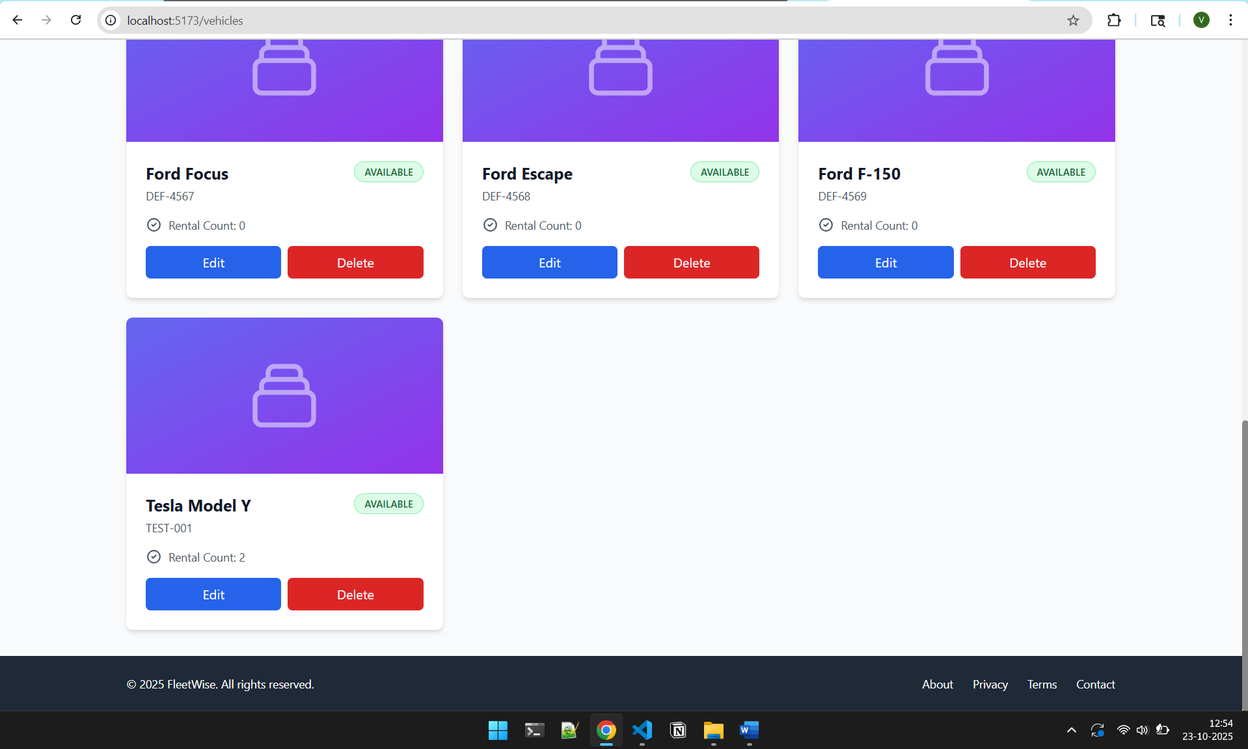

Reservation Management

Create a Reservation
- Navigate to the ”Reservations” page
- Click ”Create Reservation”
- Choose a user and an available vehicle

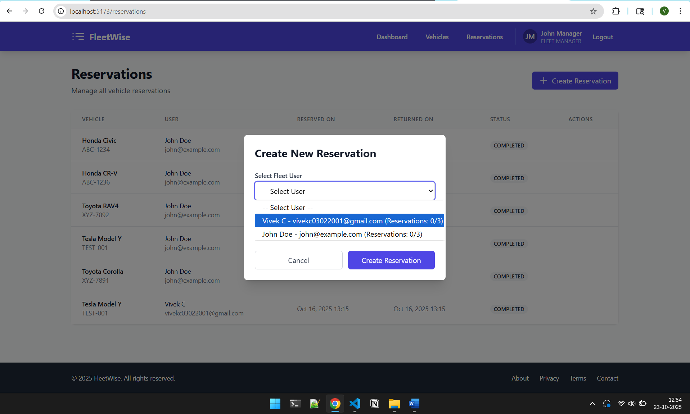

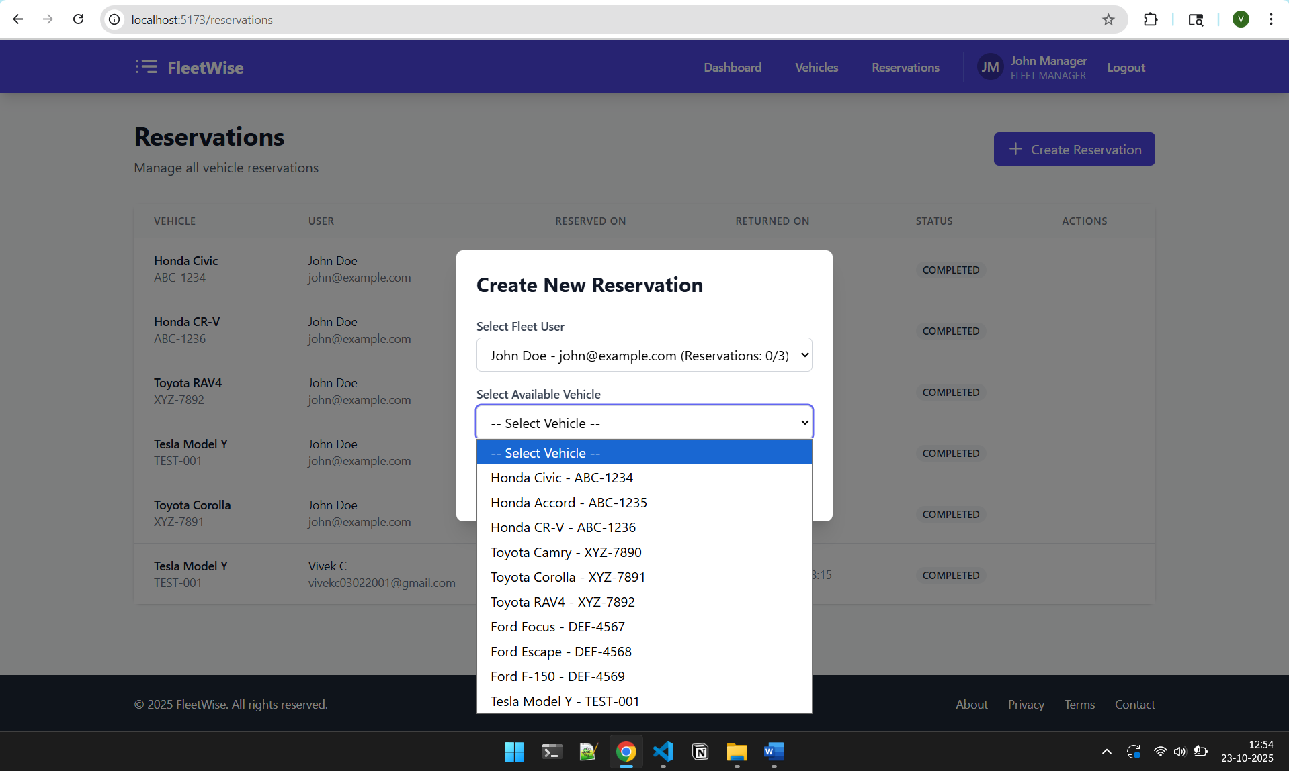
- Set the start and end dates
- Click ”Confirm”

Business Rules Enforced:
  - Users cannot have more than 3 active reservations
  - End date must be after start date
  - Vehicle must be available for the selected dates
  - Only Fleet Managers can create, modify, or delete reservations
  - Vehicle data must pass validation checks before being saved
  - User permissions are verified for each operation

Process Vehicle Return
- Open the active reservation
- Click ”Process Return”
- Confirm to mark it as completed
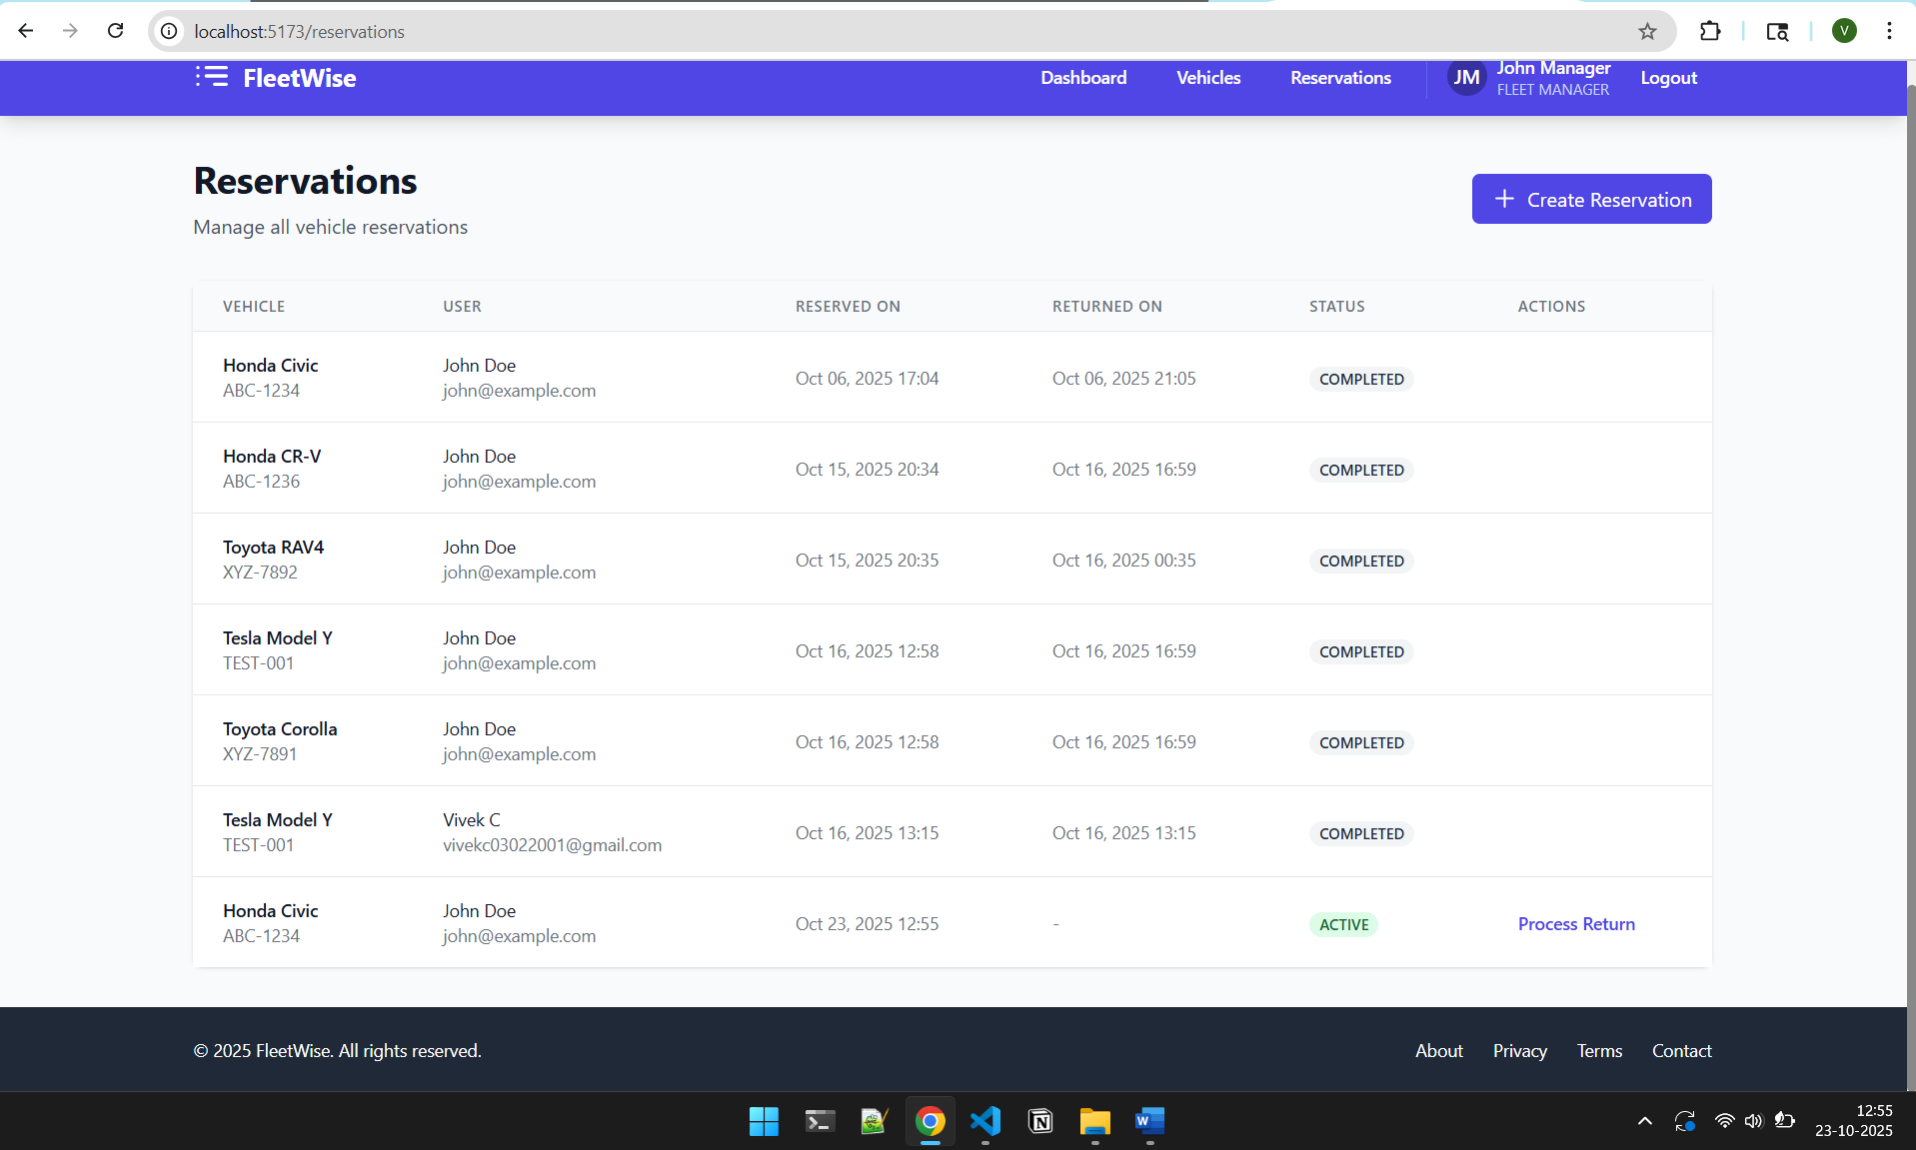

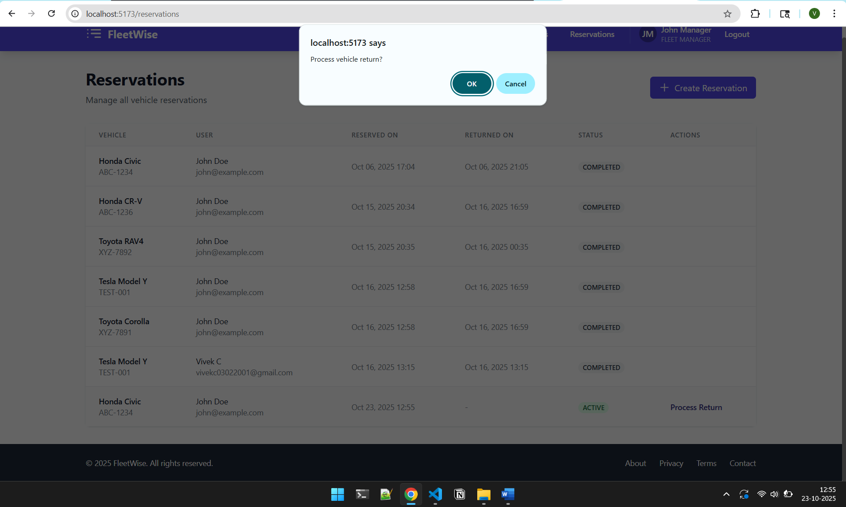

View All Reservations
Fleet Managers can filter and review all reservations:
      - Filter by status (Active or Completed)
      - Search by vehicle, user, or date

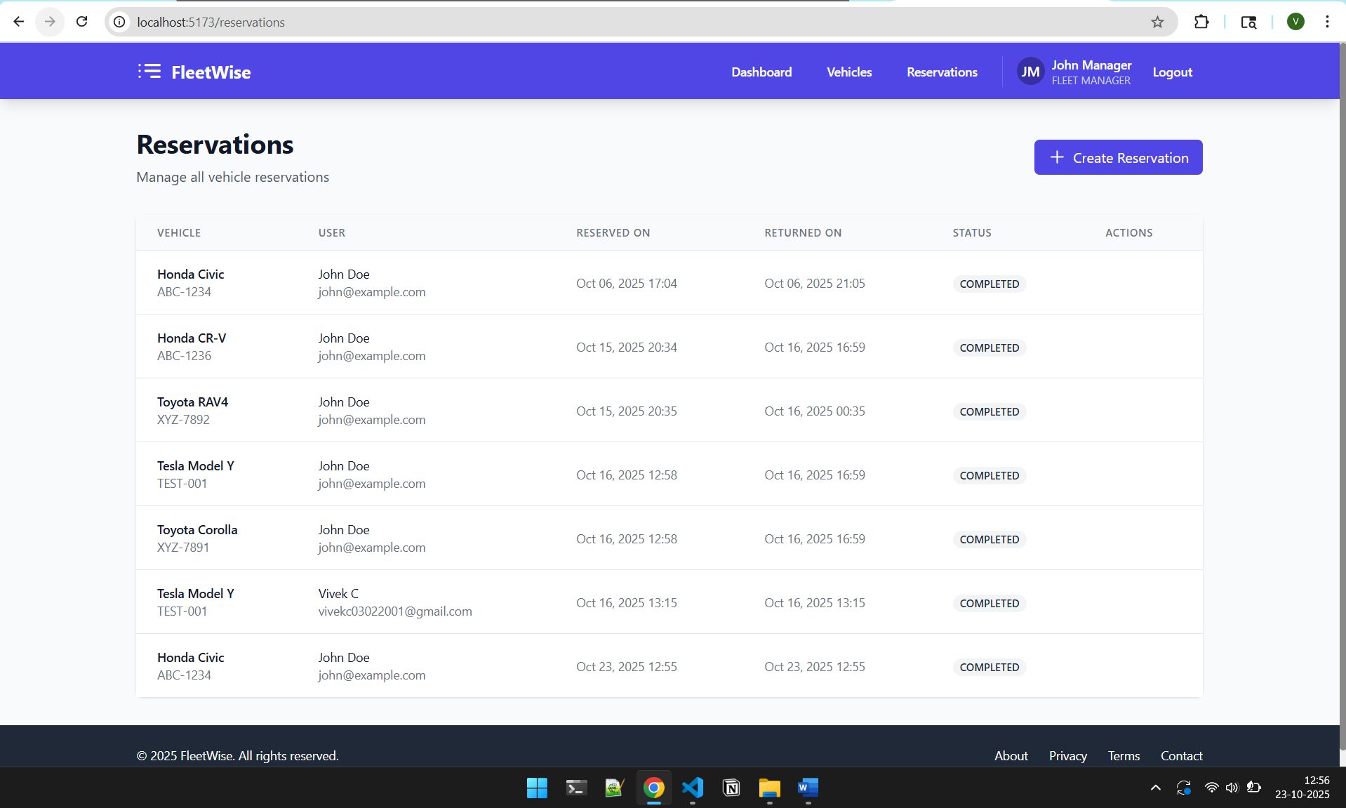

Use Case Scenarios

Use Case 1: Checking Vehicle Availability
Scenario: A Fleet User wants to check if a Toyota Camry is available.
Steps:
- Log in as a Fleet User
- Open the chatbot and select ”Toyota”
- Select ”Camry”
- The chatbot displays availability and rate

Use Case 2: Manager Creating a Reservation
Scenario: A Fleet Manager books a car for a user.
Steps:
- Log in as a Fleet Manager
- Navigate to ”Reservations” → ”Create Reservation”
- Select the user, vehicle, and duration
- Confirm to finalize

Use Case 3: Processing a Vehicle Return
Scenario: A user returns a vehicle, and the manager needs to close the reservation.
Steps:
- Log in as a Fleet Manager
- Go to the active reservation record
- Click ”Process Return”
- Confirm to complete the process

Use Case 4: User Reviewing Reservations
Scenario: A user wants to view their past reservations.
Steps:
- Log in as a Fleet User
- Open ”My Reservations”
- Review the list of active and completed bookings

Security Guidelines for Users

Best Practices
Password Management:
- Never share your password with anyone
- Use a unique password not used on other websites
- Change your password periodically
- Don’t write down your password
Session Security:
- Always log out when finished, especially on shared computers
- Don’t leave your session unattended
- Close the browser after logging out on public computers
Suspicious Activity:
- Report any unusual account activity immediately
- If you receive unexpected password reset emails, contact support
- Don’t click on suspicious links claiming to be from FleetWise

Understanding Rate Limits
If you encounter rate limit messages:
- ”Too many login attempts”
  - Wait 1 minute before trying again
  - Ensure you’re using the correct password
  - After 5 failed attempts, wait 15 minutes
- ”Too many chatbot requests”
  - Wait 1 minute before making more queries
  - You can make up to 15 queries per minute
- ”Rate limit exceeded”
  - This is rare during normal usage
  - Wait 1 minute and try again
  - If persistent, contact support

Troubleshooting

Common Issues and Solutions
Login Fails:
- Ensure correct email/password (case-sensitive)
- Check if the account exists
- Verify password meets requirements (8+ chars, uppercase, lowercase, digit, special)
- Check if account is locked (wait 15 minutes after 5 failed attempts)
- Verify you haven’t exceeded rate limit (20 attempts per minute)
- Clear browser cache and cookies
- Check if IP address is temporarily blocked
Chatbot Not Responding:
- Refresh page or restart backend
- Check if you’ve hit the rate limit (15 queries/minute)
- Ensure you’re logged in
- Try a different browser
Vehicle Not Deleting:
- Vehicle may have an active reservation
- Only Fleet Managers can delete vehicles
- Check vehicle status before attempting deletion
Page Not Loading:
- Verify both frontend and backend servers are running
- Check your internet connection
- Clear browser cache
- Try accessing in incognito/private mode
Session Expired:
- Sessions expire after 30 minutes of inactivity
- Simply log in again
- Your data is saved and will be available after re-login
Permission Denied Errors:

- Ensure you’re logged in with the correct role
- Fleet Users cannot access manager-only features
- Verify your session hasn’t expired (30-minute timeout)
- Check if your account permissions have been modified
- Log out and log in with appropriate credentials

Getting Additional Help
If you encounter persistent issues:
- Check browser console (F12 → Console tab)
- Review backend logs for API errors
- Access FastAPI documentation at http://localhost:8000/docs
- Contact support:
  - Email: vivekc03@umd.edu
  - Phone: (240) 413-6570

Reporting Security Issues
If you notice any security concerns:
- Unauthorized access to your account
- Suspicious system behavior
- Potential vulnerabilities
Immediately contact: vivekc03@umd.edu with details

Frequently Asked Questions

Account Questions
Q: How do I reset my password?
A: Contact your Fleet Manager or system administrator. Password reset functionality requires administrative access.
Q: Why was my account locked?
A: Accounts are locked after 5 failed login attempts for security. Wait 15 minutes and try again.
Q: Can I have multiple accounts?
A: No, each user should have only one account. Contact support if you need role changes.

Feature Questions
Q: Why can’t I create reservations as a Fleet User?
A: Only Fleet Managers can create reservations. Contact your Fleet Manager to book a vehicle.
Q: How many vehicles can I reserve at once?
A: Maximum 3 active reservations per user at any time.
Q: Can I cancel a reservation?
A: Contact your Fleet Manager to cancel or modify reservations.

Technical Questions
Q: Why am I getting rate limit errors?
A: Rate limits prevent system abuse. Wait 1 minute and try again. Normal usage rarely hits these limits.
Q: How long does my session last?
A: Sessions expire after 30 minutes of inactivity for security.
Q: Is my data secure?
A: Yes, FleetWise uses industry-standard security practices including password encryp-tion, secure sessions, and audit logging.

Appendix: System Requirements

Browser Compatibility
FleetWise is tested and supported on:
- Google Chrome (latest version)
- Mozilla Firefox (latest version)
- Microsoft Edge (latest version)
- Safari (latest version)

Network Requirements
- Stable internet connection
- Access to http://localhost:5173 (frontend)
- Access to http://localhost:8000 (backend API)

Screen Resolution
- Minimum: 1024x768
- Recommended: 1920x1080 or higher
- Responsive design supports mobile devices

Conclusion
FleetWise provides a secure, user-friendly platform for managing corporate vehicle fleets. This guide has covered all major features, security measures, and troubleshooting steps to help you make the most of the system.

Key Takeaways:
- Always use strong passwords meeting the requirements
- Be aware of rate limits during heavy usage
- Log out when finished for security
- Report any security concerns immediately
- Contact support for assistance
For questions or support:
- Email: vivekc03@umd.edu
- Phone: (240) 413-6570

